NEXT BASKET Test Cases

**Feature: Checkout Process**

Scenario: Successfully add an item to the cart

Given the user is on the product page

When the user clicks on "Add to basket" button

Then the item should be added to the cart

And the cart should show the correct item and quantity

**Scenario: Apply a discount code**

Given the user has items in the cart

When the user enters a valid discount code

And clicks on "Apply" button

Then the discount should be applied to the cart total

**Scenario: Remove an item from the cart**

Given the user has items in the cart

When the user clicks on "Remove" button next to an item

Then the item should be removed from the cart

And the cart total should be updated accordingly

**Scenario: Proceed to checkout**

Given the user has items in the cart

When the user clicks on "Go to payment" button

Then the user should be redirected to the checkout page

**Scenario: Enter shipping information**

Given the user is on the checkout page

When the user enters valid shipping information

And clicks on "Continue" button

Then the shipping information should be saved

And the user should proceed to the payment section

**Scenario: Select shipping method**

Given the user is on the checkout page

When the user selects a shipping method

And clicks on "Continue" button

Then the selected shipping method should be saved

And the user should proceed to the payment section

**Scenario: Complete payment with valid credit card**

Given the user is on the payment section

When the user enters valid credit card details

And clicks on "Pay" button

Then the payment should be processed successfully

And the user should see a confirmation message

**Scenario: Attempt to complete payment with invalid credit card**

Given the user is on the payment section

When the user enters invalid credit card details

And clicks on "Pay" button

Then the payment should be declined

And the user should see an error message

**Scenario: View order summary before finalizing order**

Given the user has entered shipping and payment information

When the user clicks on "Review order" button

Then the user should see an order summary with all details

And the user can confirm or modify the order

**Scenario: Successfully place an order**

Given the user has reviewed the order summary

When the user clicks on "Place order" button

Then the order should be placed successfully

And the user should see an order confirmation page

And the user should receive an order confirmation email

**Bug Report**

**Bug 1: Phone Masking Not Applied**

**ID:** BUG-001

**Title:** Phone masking not applied

**Description:** The phone number input field does not have masking applied. Users can enter characters or formats that are not valid for phone numbers, which could lead to incorrect data submission.

**Steps to Reproduce:**

1. Navigate to the Checkout information page.
2. Enter any characters in the phone number input field.

**Expected Result:** The phone number input field should have a masking format that only allows valid phone numbers to be entered.

**Actual Result:** The phone number input field accepts any characters without any masking applied.

**Severity:** High

**Priority:** High

**Environment:**

* Browser: Chrome 127.0.6533.89
* OS: Windows 10

**Attachments:** 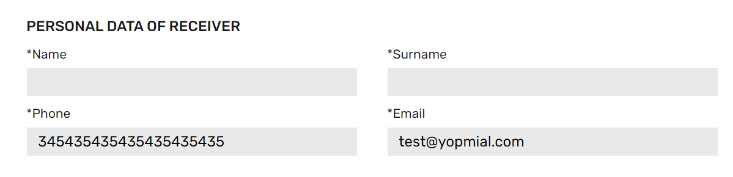

**Bug 2: Terms and Conditions Link Not Working**

**ID:** BUG-002

**Title:** Terms and Conditions link not working

**Description:** The link to the terms and conditions page is not functional. Clicking on it does not redirect to the intended page, leading to user frustration.

**Steps to Reproduce:**

1. Navigate to the checkout page.
2. Click on the "Terms and Conditions" link.

**Expected Result:** The link should redirect to the terms and conditions page.

**Actual Result:** Nothing happens when clicking on the link.

**Severity:** Medium

**Priority:** Medium

**Environment:**

* Browser: Chrome 127.0.6533.89
* OS: Windows 10

**Bug 3: Spacing Issue with First Name and Username in Email**

**ID:** BUG-003

**Title:** Spacing issue with first name and username in email

**Description:** There is a spacing issue between the first name and username in the email sent to users. This affects the readability of the email content.

**Steps to Reproduce:**

1. Register a new account or trigger an email containing the first name and username.
2. Open the received email.

**Expected Result:** The first name and username should be properly spaced in the email.

**Actual Result:** There is an improper spacing between the first name and username, affecting readability.

**Severity:** Low

**Priority:** Low

**Environment:**

* Email Client: Gmail (Web)
* Browser: Chrome 127.0.6533.89
* OS: Windows 10

**Attachments:** 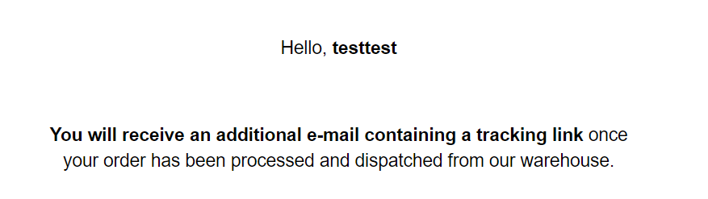

**Bug 4: Product Tab Shows "null" Instead of Product Name**

**ID:** BUG-004

**Title:** Product tab shows "null" instead of product name

**Description:** When clicking on the “Painting A” product, the browser tab shows "Painting A | null" instead of the correct product name.

**Steps to Reproduce:**

1. Navigate to the product listing page.
2. Click on the “Painting A” product.

**Expected Result:** The browser tab should show "Painting A | [Site Name]".

**Actual Result:** The browser tab shows "Painting A | null".

**Severity:** Medium

**Priority:** Medium

**Environment:**

* Browser: Chrome 127.0.6533.89
* OS: Windows 10

**Attachments:**

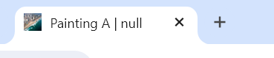

**Summary**

This bug report identifies four issues:

1. Phone masking not applied in the contact information page.
2. Non-functional terms and conditions link.
3. Spacing issue with the first name and username in the email.
4. Product tab showing "null" instead of the product name.